**BUSINESS REPORT**

This report provides an analysis of **a supermarket sales data from 2016 to 2019**, highlighting **key trends** in **sales**, **profits**, and **customer behavior**. It aims to offer actionable insights for enhancing strategic decisions and improving business performance.

During the given period, **sales trends** showed consistent **growth** with **seasonal fluctuations**. Overall, consumers accounted for the highest sales. Sales typically rose from Q1, **peaked around mid-year (Q3),** and **declined towards year-end** (**Q4**). In 2016, consumer sales started at 25K in Q1, peaked at 100K in Q4. Corporate and Home Offices are also followed similar seasonal patterns, with Corporate sales peaking at 50K and Home Office 30K in 2016. As a result, **focus on running more promotions from Q3** can help to boost the store’s sales.

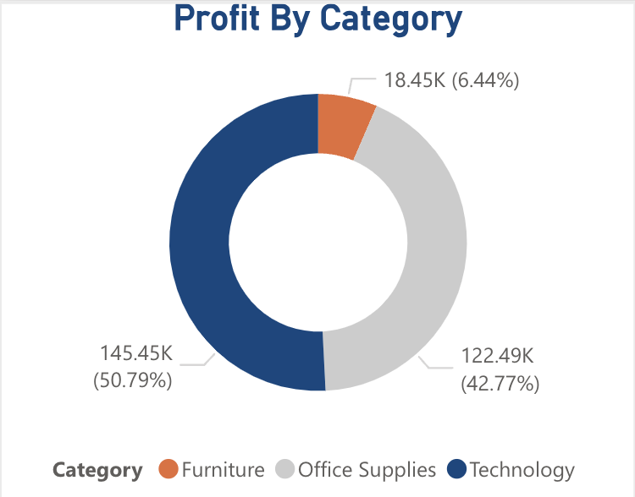

Focus more on the profit distribution by product category. **Technology** led with the **highest contribution**, bringing 145.5K and representing **50.79% of the store’s total profit**, followed by Office Supplies for 122.49K (42.77%), and Furniture with 18.45K (6.44% of total profit).

The chart highlights that **Technology and Office Supplies are the primary drivers for total profit**, with Technology slightly ahead. Furniture contributes the least to the profit.

Focus **promotional efforts** on **Technology and Office Supplies**, as they yield the highest profits. Additionally, **develop strategies to enhance Furniture sales.**

**Focus on the top performing region shown by the map below:**

The map highlights the **top three states in term of sales**. California led with the highest sales at $457,687K, followed by New York with sales amounting for $310,870K and Texas with sales totaling 170,188K during the given period. These states are shown in the darker shades on the map, indicating their significant contributing to overall store’s sale.

**Monitoring, analyzing sale market trends** and **consumers’ feedback** in these top-performing state to **stay ahead of competitor and sustain growth.**

While most of store’s customers are from other suburbs, the **shipping segment plays an important role** in **customer satisfaction**. Efficient and timely shipping lead to higher customer satisfaction, boosting repeat purchases and overall sales.

The chart beside display **the average days to ship** for First Class, Second Class, and Standard Class shipping modes **from 2016 to 2019**. First Class consistently averages around 2 days, while Second Class and Standard Class take around 3.5 to 5 days respectively.

Overall, the average shipping days, represented by the black line. While the **average shipping days in 2016** was **3.5 days**, it increased to approximately 6 days in 2017, then they made a big improvement to slowly decreased the **average shipping days to 1** **in 2019**.

**ADVISE FOR THE MARKETING TEAM**:

* Based on the seasonal sales trend on graph 1, Marketing Team should **focus campaign from Q3** to leverage peak sales periods. Aligns promotional activities with peak consumer activity, **optimizing sales and profit.**
* Especially, prioritize marketing **campaigns for Technology and Office Supplies** to boost high-profit categories. Create **special offer** for **Furniture** to increase its contribution.
* **Concentrate resources** in **California, Texas** and **New York**. Replicate successful strategies from these states in other regions
* **Promote** efficient **First-Class shipping times**. Keep improve and consistent with the average shipping days to **enhance customer trust loyalty.**